**Phase 8: Data Management & Deployment**

**Data Import Wizard**

* A **user-friendly, declarative tool** in Salesforce to import small to medium data volumes (up to 50,000 records) via CSV files.
* **Alignment with CharityConnect:**
  + Initial import of donor base with details such as name, email, contact, preferred causes, and historical loyalty points.
  + Import of pre-existing campaigns (Education Drive, Healthcare Relief, Disaster Relief) to set up the org quickly.
* **Benefit:** No coding required; ideal for NGO staff/admins to quickly populate the system without developer intervention.

**Data Loader**

* A **client-based tool** for bulk operations (insert, update, delete, export) capable of handling **millions of records**.
* **Use Case in CharityConnect:**
  + Import historical donation data spanning multiple years.
  + Update existing donation statuses in bulk after payment gateway reconciliation.
  + Export large datasets for audits or reporting.
* **Alignment:** Ensures that large-scale donor and donation information is migrated efficiently and accurately.

**Duplicate Rules**

* Prevents **duplicate records** for Donors, Donations, and Beneficiaries.
* **Mechanism:** Matching criteria like email, phone number, and donor ID ensures data integrity.
* **Use Case:** If multiple NGO staff attempt to import donor data, duplicates are automatically flagged or blocked.
* **Benefit:** Maintains a **clean, trustworthy donor database**, crucial for transparency.

**Data Export & Backup**

* Salesforce provides options for **manual and scheduled data exports** for compliance, auditing, and disaster recovery.
* **Use Case in CharityConnect:**
  + Weekly or monthly export of Donation and Campaign records for **CSR audit and regulatory reporting**.
  + Backup of donor loyalty points and badges to prevent accidental data loss.
* **Benefit:** Provides NGOs with **secure historical records** and peace of mind about data safety.

**Change Sets**

* Declarative method to deploy metadata between Salesforce orgs (Sandbox → Production).
* **Use Case in CharityConnect:**
  + Deploy newly configured Flows for **Badge Assignment** and **Campaign Reporting** from UAT sandbox to live org.
  + Deploy updates to Custom Objects (Donor, Donation, Donor Badge) and Page Layouts without manual recreation.
* **Benefit:** Ensures **consistent configuration and automation** across environments.

**Unmanaged vs Managed Packages**

* **Unmanaged Packages:** Internal deployments; metadata editable after installation.
* **Managed Packages:** For distribution via AppExchange; metadata mostly locked.
* **Use Case in CharityConnect:**
  + Unmanaged Package to deploy custom objects, Flows, and LWC components to another NGO org if needed.
* **Benefit:** Facilitates **reuse and modular deployment** while maintaining flexibility.

**ANT Migration Tool**

* A **command-line tool** for deploying metadata in a scripted manner, ideal for **advanced deployments or CI/CD pipelines**.
* **Use Case in CharityConnect:**
  + Automate migration of complex metadata like **Donation Flows, Badge Assignment logic, and Apex triggers** from Sandbox to Production.
* **Benefit:** Reduces human errors and speeds up deployment of large-scale projects.

**VS Code & Salesforce DX (SFDX)**

* Provides a **developer-centric environment** for building, version controlling, and deploying Salesforce components.
* **Use Case in CharityConnect:**
  + Developers create Apex triggers for Donation and Badge logic in **scratch orgs**, test locally, then deploy using SFDX.
  + Version control via GitHub ensures changes are tracked, collaborative, and reversible.
* **Benefit:** Supports **agile development**, safe testing, and continuous deployment for NGO projects.

**Screenshots:**

**Data wizard**

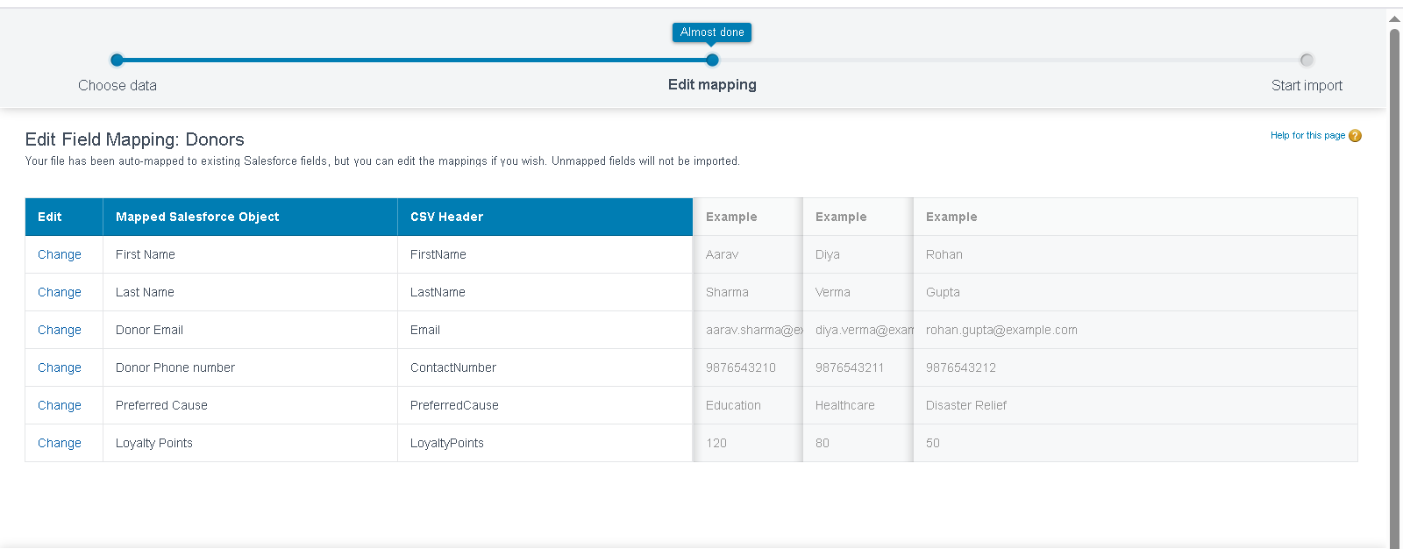

**duplicate rule**

